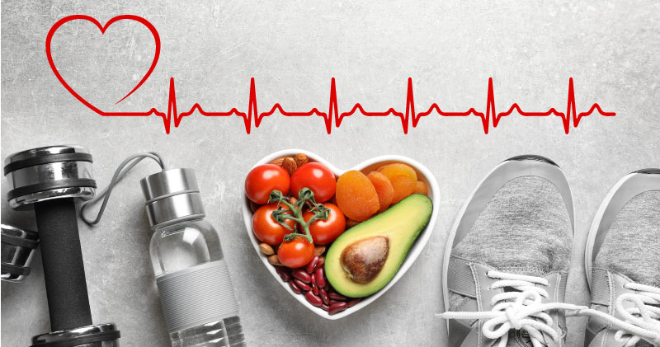
THE BEST WEAPONS TO PREVENT HEART DISEASE

A healthy diet and lifestyle are your best weapons to fight cardiovascular disease. It’s not as hard as you may think! Remember, it's the overall pattern of your choices that counts. Make the simple steps below part of your life for long-term benefits to your health and your heart.

+ Consistent exercise – every little bit counts!
+ Manage stress in a healthy way
+ Increase fruits and vegetables
+ Make whole grains your first choice

Interested in learning more? Click here

Visit your healthcare provider for a healthy heart exam, including checking your blood pressure and cholesterol levels. Your care team can also provide support with developing and maintaining lifestyle choices that help promote a healthy heart. Reach out today to make your appointment!

