1 teaspoon of sugar
= 4 grams of sugar
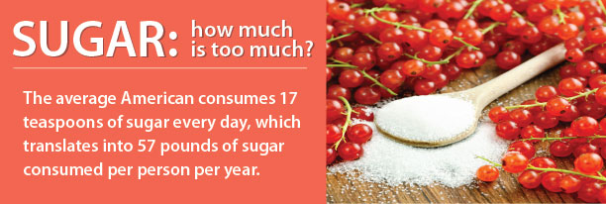
Reading food labels is one of the best ways to monitor your intake of added sugar. New nutrition labels will break out “added sugars” from total sugar, helping you easily identify and limit added sugar from your diet.  Interested in learning more? Click here | 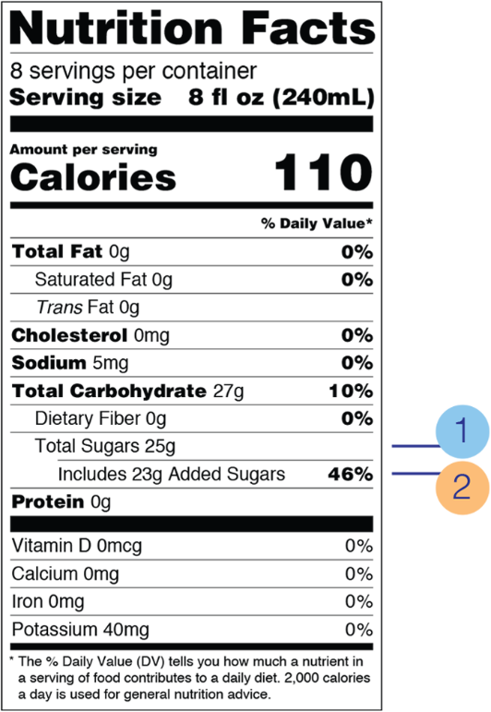
Call your healthcare provider today to get support in limiting your sugar intake and lowering your risk of developing diabetes.

