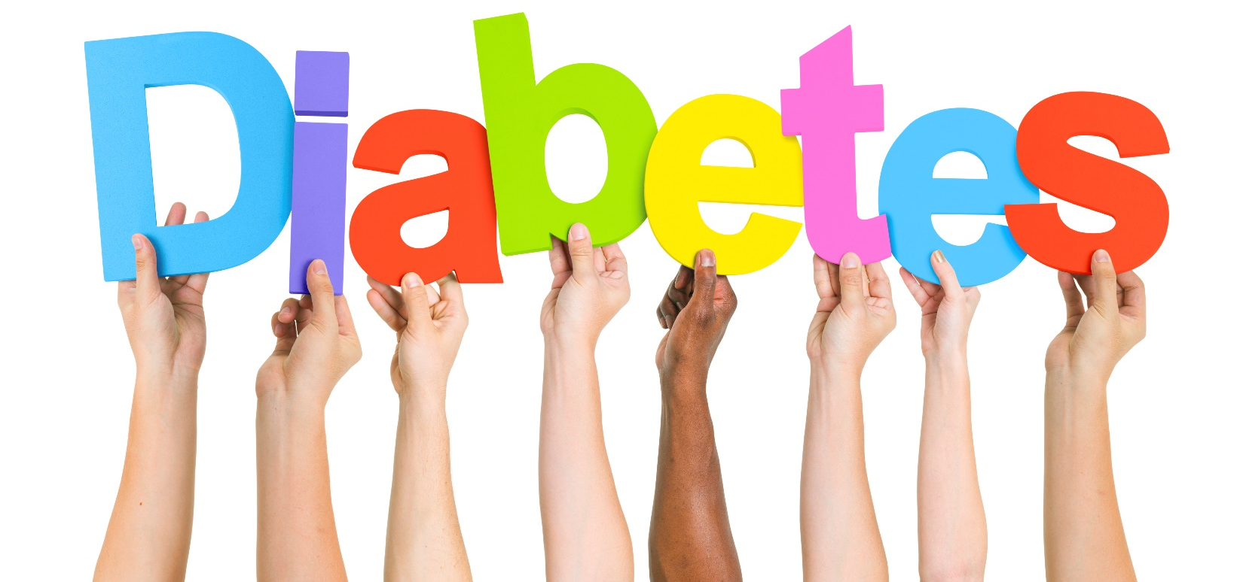
Did you know? More than one out of three American adults have prediabetes. Nine out of ten people with prediabetes don’t know they have it!

There’s good news, however. Progression from prediabetes to type 2 diabetes isn’t inevitable. Eating heathy foods, making physical activity part of your daily routine and staying at a healthy weight can help bring your blood sugar level back to normal.

Click here for the full article.

Call your healthcare provider today to schedule an appointment to find out if you are at risk of developing diabetes.

