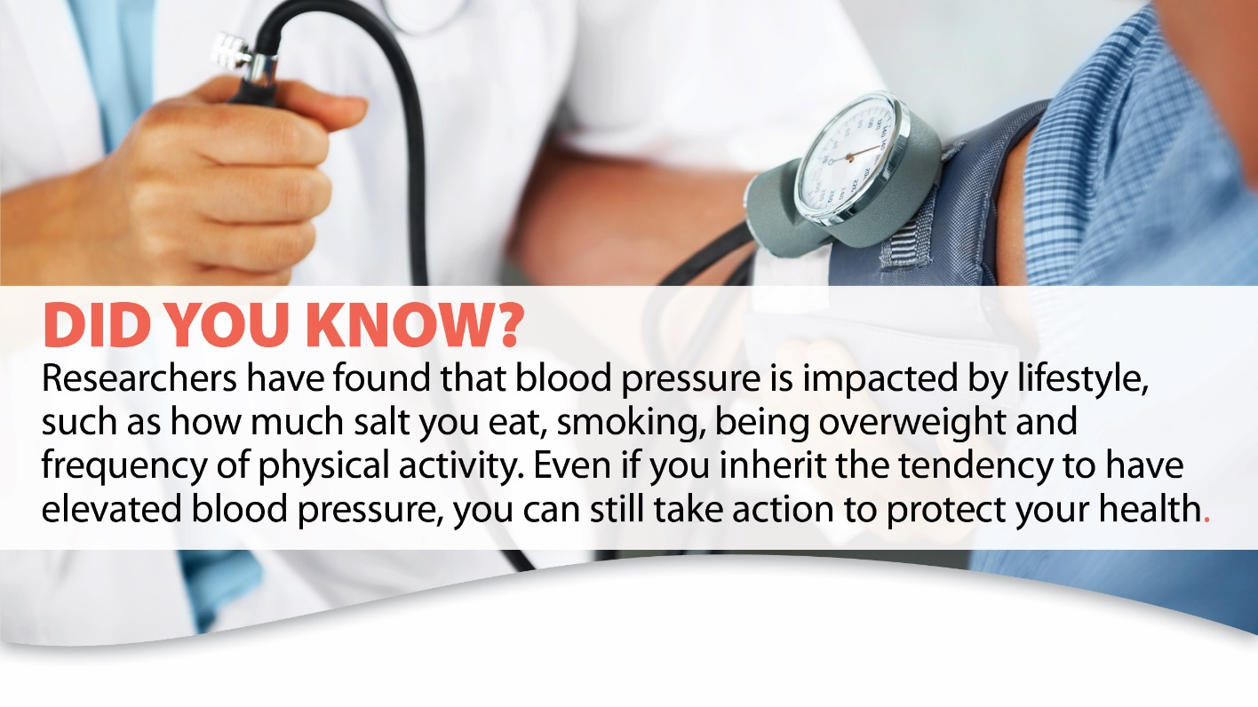
So, what can you do to help keep your heart healthy?

Start where you are. If you wish to focus on creating heart healthy habits, making small changes and sticking with that change will have a huge impact!

Ideas to try:
- Eat a variety of fruits and vegetables. Low in calories and high in fiber, they can help prevent cardiovascular disease. Try adding an extra serving of veggies with every meal.
- Make it Whole Grains. Whole grains are an essential part of a healthy diet and can help improve blood pressure and cholesterol levels while lowering the risk of heart disease.
- Watch portion sizes. How much you eat is just as important as what you eat. Using smaller plates and boxing up half your meal when eating out can help.
- Move more. Park farther away, take the stairs, or do a quick lap around the store are all ways to help you move more throughout the day.
- Stress Well. How much stress you experience and how you react to it can lead to a variety of health problems. Take a deep breath or count to 10 before reacting to a stressful situation.

Interested in learning more? Click here. No matter which tip you go with, it is all a win: make an appointment to find out what your heart is saying!

